**Name – Parag Gattani**

Program No. – 11

Program Title – Vibration motor and LDR

**AIM**

To design an automated day indicator system.

**HARDWARES REQUIRED**

* Arduino Board
* NPN Transistor
* Resistor
* Vibration motor
* Multimeter
* Photoresistor

**CIRCUIT DIAGRAM**

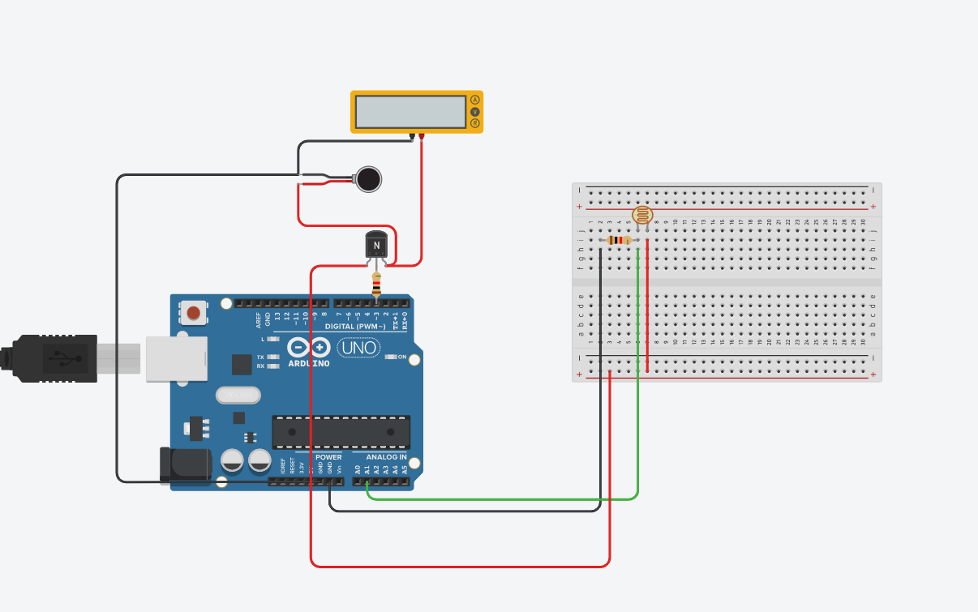

**WRITE-UP**

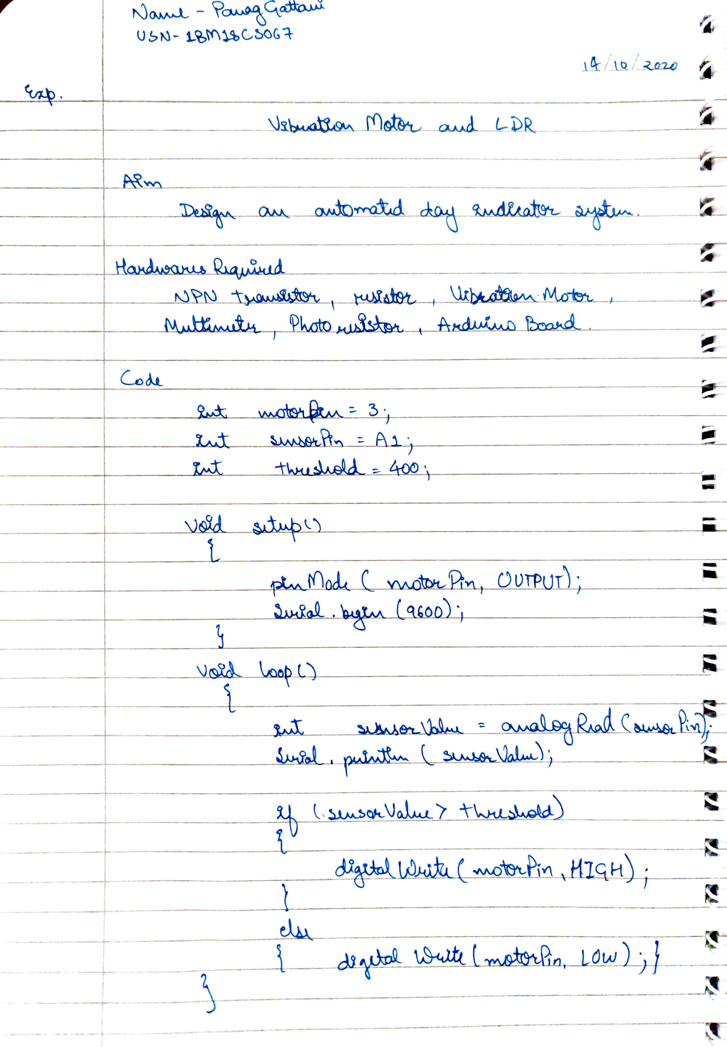

**CODE**

int motorPin = 3;

int sensorPin = A1;

int threshold = 400;

void setup()

{

pinMode(motorPin, OUTPUT);

Serial.begin(9600);

}

void loop()

{

int sensorValue = analogRead(sensorPin);

Serial.println(sensorValue);

if(sensorValue > threshold)

{

digitalWrite(motorPin, HIGH);

}

else

{

digitalWrite(motorPin, LOW);

}

}

**OUTPUT**

Designed an automated day indicator system.